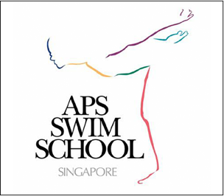
APS SWIM SCHOOL (S) PTE LTD
Email: admin@apsswim.com
Tel: 67775823
Mailing address: Orchard P.O. Box 788, S(912327)

Discontinuation of Class Form
Please ensure all the information is filled out and email to admin@apsswim.com.

Personal Information
Student Full Name: Parent Full Name: Contact No.

Current Class Information
Day of Lesson: Lesson Time: Location:

Program:
LTS
Endurance
Cross Training
Learn-To-Synchro
Learn-To-Dive
APSC (BLUESKY/JETFIRE/REDWHITE/SYNCRHO/DIVING)

Present Swim Teacher:

I would like to discontinue my child’s class. In view of the one-month notice, the last day of swimming lesion shall be (day) / (month) / (year)

For record purposes, we would appreciate it very much if you could kindly provide your reasons.

Away for holiday Exams Passed Station 8 Unsuitable Schedule

Leaving the country My child is no longer keen

Medical reason ~ Kindly attach medical certificate to discontinue class with immediate effect

Program did not meet my objective (please provide any suggestion/feedback for us to improve upon):
Others :

**For the above reasons, please note that upon discontinue the class, the current slot may be assigned to the next student who is requesting for the same day/time.

** If you would like to re-register for class, please fill out the re-registration form and email to us at classplacement@apsswim.com. Once we receive the form, we will revert to you regarding the available slot for your child.

** Please note if lessons are stopped for more than 3 months (Learn-To-Swim program) or more than 6 months (Endurance program), the child will need a re-evaluation before a class time is scheduled.

Parent/Guardian Signature (electronic): Date:

